OBJECTION PROCESS

Only those who submitted written comments during a public comment period (scoping or DEIS comments) are eligible to file an objection.

How to Object and Timeframe: Written objections, including any attachments, must be sent via regular mail to Objection Reviewing Officer, USDA-Forest Service Intermountain Region, 324 25th Street, Ogden, UT 84401 or email objection to objections-intermtn-regional-office@usda.gov within 45 days following the publication of the legal notice in the Casper Star-Tribune (November 23).

36 CFR § 218.8
Filing an objection.
(a) Objections must be filed with the reviewing officer in writing. All objections are available for public inspection during and after the objection process.
Incorporation of documents by reference is not allowed, except for the following list of items that may be referenced by including date, page, and section of the cited document, along with a description of its content and applicability to the objection. All other documents must be included with the objection.
(1) All or any part of a Federal law or regulation.
(2) Forest Service directives and land management plans.
(3) Documents referenced by the Forest Service in the proposed project EA or EIS that is subject to objection.
(4) Comments previously provided to the Forest Service by the objector during public involvement opportunities for the proposed project where written comments were requested by the responsible official.
(c) Issues raised in objections must be based on previously submitted specific written comments regarding the proposed project or activity and attributed to the objector, unless the issue is based on new information that arose after the opportunities for comment. The burden is on the objector to demonstrate compliance with this requirement for objection issues (see paragraph (d)(6) of this section).
(d) At a minimum, an objection must include the following:
(1) Objector's name and address as defined in § 218.2, with a telephone number, if available;
(2) Signature or other verification of authorship upon request (a scanned signature for electronic mail may be filed with the objection);
(3) When multiple names are listed on an objection, identification of the lead objector as defined in § 218.2. Verification of the identity of the lead objector must be provided upon request or the reviewing officer will designate a lead objector as provided in § 218.5(d);
(4) The name of the proposed project, the name and title of the responsible official, and the name(s) of the national forest(s) and/or ranger district(s) on which the proposed project will be implemented;
(5) A description of those aspects of the proposed project addressed by the objection, including specific issues related to the proposed project; if applicable, how the objector believes the environmental analysis or draft decision specifically violates law, regulation, or policy; suggested remedies that would resolve the objection; supporting reasons for the reviewing officer to consider; and
(6) A statement that demonstrates the connection between prior specific written comments on the particular proposed project or activity and the content of the objection, unless the objection concerns an issue that arose after the designated opportunity(ies) for comment (see paragraph (c) of this section).
Front matter for the objection letter:

RE: Project 54201 Snow King Mountain Resort On-Mountain Improvements; Jackson Ranger District, Bridger-Teton National Forest, Teton County, Wyoming. The Supervisor of the Bridger-Teton is the responsible official for this decision.

Objection Reviewing Officer
USDA-Forest Service Intermountain Region
324 25th Street, Ogden, UT 84401
objections-intermtn-regional-office@usda.gov

Narrative of aspects of the proposal being objected to:

List the specifics as desired, whether one item or many. Follow the template from item (d)(5) above.

Example narrative for one issue:
The face road as currently configured is “needed” to construct and service a large restaurant-bar-meeting complex on the summit, not to provide a beginner skier route. None of the alternatives consider a different road alignment.

The road as proposed violates the Ski Area Outdoor Recreation Enhancement Act (SAOREA) Sec 3, page H.R 765-2, 2011, which states that each facility authorized “shall harmonize with the natural environment of the National Forest System land on which the activity or facility is located and be located within the developed portions of the ski area.”

Suggested remedy: Consider alternatives to the proposed road location, alignment and width, to include those that would serve facilities less extensive than proposed.

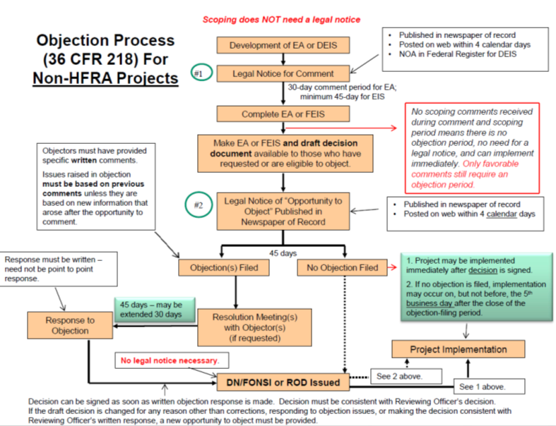

In this case, the Regional Forester
For example, include as an attachment a document such as a research paper.
Make sure to follow this guidance to avoid having an objection dismissed. They’ll be looking for reasons to do so.

